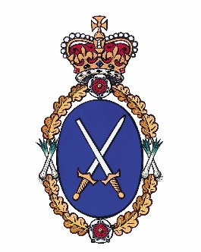

West Glamorgan
High Sheriff’s Awards 2020

For young people and adults, youth groups and clubs, and community organisations who VOLUNTARILY make an outstanding effort and contribution to their local community.

MESSAGE FROM THE HIGH SHERIFF

Each year the High Sheriff acknowledges the enormous contribution made by volunteers to society through the High Sheriff Awards. I have been privileged to meet so many volunteers who are making a real difference to communities and the lives of others by giving up their time freely and without expectation of reward.

The High Sheriff awards provide an opportunity for the selfless dedication of our volunteers to be acknowledged and celebrated.

Many young people devote significant amounts of time to volunteering and their circumstances can often be difficult because of caring responsibilities or the effects of unemployment on family life. A High Sheriff award, which recognises the impact of their volunteering, can give young people confidence in their abilities and inspire the next generation

The contribution of adults who support young people is also recognised through the awards which can be given to individuals or groups.

I look forward to receiving your nomination so that at this year’s awards ceremony there can be a real celebration of the impact of volunteering in West Glamorgan.

Sally Goldstone

Sally R Goldstone
High Sheriff of West Glamorgan 2019 – 2020

High Sheriff Awards

The High Sheriff of West Glamorgan would like to recognise any individual (young person or adult) or group which has made, or is making, a sustained and VOLUNTARY effort to help their local community.

There are two categories of award:
- For adults VOLUNTARILY helping young people
- For young people VOLUNTARILY helping their local community

Do you know of anyone who makes a difference in their community?
If so, why not nominate them for an award?

All you have to do is fill in this form and post it to the High Sheriff. Your nominee could be one of those people who will receive an award and the deserved recognition of their community.

The 2020 High Sheriff’s Awards will be held on:
Saturday 28th March 2020 at 10.30am
Mumbles Cricket Club
Marespool Ground, Old Plunch Lane, Thistleboon, Mumbles
Swansea SA3 4JE

The closing date for nominations is Wednesday 4th March 2020

Please forward your completed nomination form to:
The High Sheriff’s Award Panel
c/o Sian Morris
Community Safety Team
Neath Police Station
Gnoll Park Road
NEATH SA11 3BW

(for electronic applications send to s.morris@npt.gov.uk)

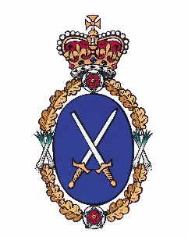

HIGH SHERIFF’S AWARDS
NOMINATION FORM

1. Who do you want to nominate: ………………………………………………………………………

2. Name of organisation served: ………………………………………………………………………

3. Length of service: ……………………………………………………………………….

4. Address of nominee: ………………………………………………………….……………………..

…………………………………………………………….…………………..

……………………………………………………...…………………………

5. Email address if known: ….……………………………………………………………...………………

6. Telephone number: …………………………..…………………………………..………………….

7. Category of award (please tick appropriate box)

Young person Adult Joint Group

8. About yourself, the person making the nomination:
(If we need more information, we may get in touch)

Relationship to the nominee: …………………………………………..…………………………..……….

Your name: …………………………………………………………….………………….

Your address: ………………………………………………………………….…………….

………………………………………………………………….…………….

…………………………………………………………….………………….

E mail address: ……………………………………………………………...….………………

Telephone No. (daytime): ……………………………………………………………..………………….

Telephone No. (evening): ……………………………………….………………………………………..

Continue on next page

9. Why does this person / group / organisation deserve an award?
The information below will be used at the award ceremony to highlight what your nominee has achieved (please use a maximum of 250 words)

You may attach photographs and supporting evidence if you wish.

For further forms, information or advice, please ring
Siân Morris on 01639 889161 or Paul Evans on 07796 275107
s.morris@npt.gov.uk Paul.evans3@swansea.gov.uk
This application form is also available in Welsh.

